**Webpage Link DiscoveryIntroduction**

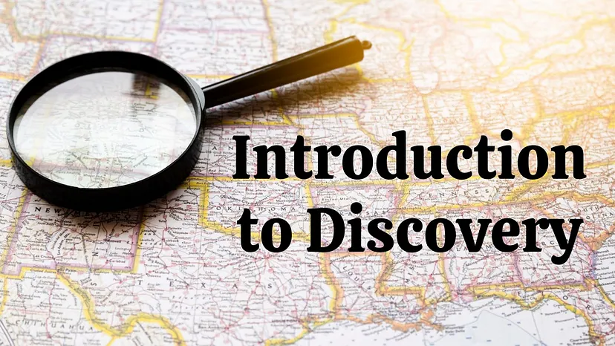

**Introduction:**



Link Grabber is a Chrome extension that allows users to extract and analyze links from any webpage. This Capture the Flag (CTF) scenario introduces beginners to the basics of using the Link Grabber extension to discover and analyze links on a given webpage.

**Scenario**

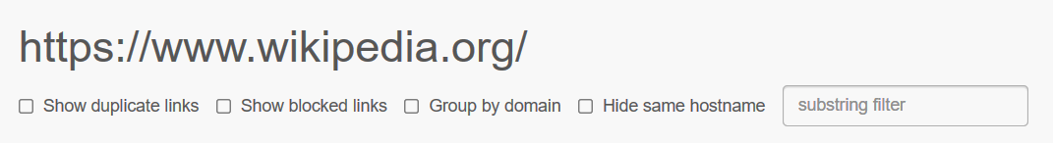

In this scenario, you will use the Link Grabber extension to extract and analyze links from a specific webpage. Your tasks include identifying different types of links and specific link attributes to capture flags.

**Process**

Step 1: Go to the link and add extension on your chrome browser <https://chromewebstore.google.com/detail/link-grabber/caodelkhipncidmoebgbbeemedohcdma>

Step 2: Go the Wikipedia home page and open the extension which you can open from the top right of your screen <https://www.wikipedia.org/>

Step 3: Capture the flag.

**Questions**

**Flag 1: How many links are shown out of the total?**

Answer: 350

Flag Captured.

**Flag 2: What is the URL of the first external link found on the Wikipedia homepage?**

Answer: <https://en.wikipedia.org/wiki/Main_Page>

Flag Captured.

**Hint**

